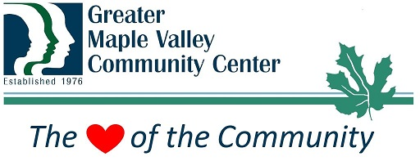
Position Description: Rental Assistant

Summary Statement
Under general supervision from the Community Center Executive Director, the individual in this position is responsible for maintaining a safe, clean facility and successful facility rentals supervision/customer service. Responsibilities include ensuring proper use of facility & equipment by renters and performing regular and event-related janitorial duties. The position is part-time, 30 hours/week. Includes weekend and evening shifts.

General Duties and Responsibilities

Facility Maintenance Duties and Responsibilities
- Maintain cleanliness of main building and Den
- Maintain grounds and exterior of building
- Assess, order and maintain maintenance equipment and supplies
- Supervise volunteers and court ordered community service workers to assist with duties

Facility Rental Duties and Responsibilities
- Maintain security and condition of building & equipment used for rentals
- Check rentals in
- Assist rentals with set up and take down of chairs, tables, etc.
- Assist with rentals as needed
- Check rentals out at the conclusion of event

Other
- A combination of early morning hours, evening and weekend shifts are included.
- Part of the team on the emergency call list for 24/7 fire & security system

Knowledge, Abilities, Skills:
- Physical ability to perform cleaning/maintenance duties, such as:
- bend, kneel, push, pull, reach,
- lift 50 pounds
- use ladder, basic hand tools, lawnmower, blower, etc.
- replace bulbs and batteries in ceiling fixtures
- move furniture & equipment
- Exceptional customer service

Compensation
$18/hr. @ 20 hours per week. Open until filled.

Submit resume or work history to markp@maplevalleycc.org or return to:
Greater Maple Valley Community Center
22010 SE 248th St.
Maple Valley, WA 98038
Programs/Job Descriptions/Current Jobs/ Rental Assistant 10-9-23

